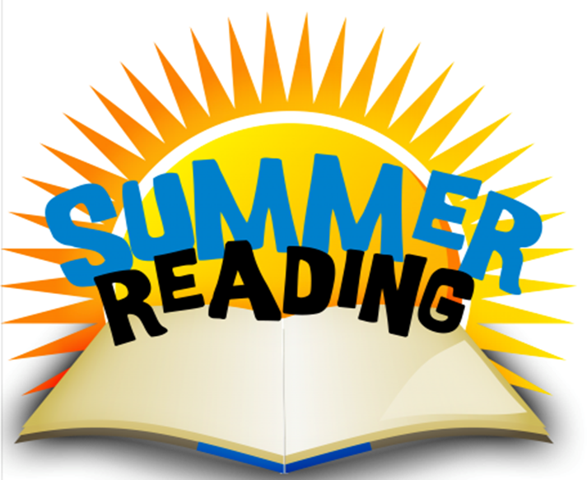

Summer Reading Fun @ Maverick Library
8700 Mystic Park

Come relax and read with some of our
Brauchle teachers!

Time: 12:00 PM – 1:00 PM
Tuesdays
June 13th - get a giant READ sticker to color

June 20th - make a silly corner bookmark

June 27th – make a pinwheel

July 11th – make a Lego Batman finger puppet

July 18th – it’s a surprise!

