This summer, it’s
all about
YOU!
Brauchle Library
Summer Reading 2017
Be the star of your own
summer reading adventure!

- You can read whatever YOU want! No one’s telling you what to read! Books above your reading level? Who cares?! Books “too easy?” It doesn’t matter! YOUR’RE in charge!
- YOU can choose to do some of the challenges in this packet...or not!
- You can choose to read wherever or whenever YOU want because it's summer!
- You can read all day if you want to. Or all night!
- You can do whatever YOU want! Just make sure you have fun and read, read, read!

Have a GREAT Summer!
A Note to Parents
Dear Parents,
Did you know that reading is one of the biggest predictors of success in life? Students who read more books become better readers. Students who read well have higher levels of academic success. People with higher levels of reading and writing skills do better in the job market and are more engaged with society and culture. The 2007 National Endowment for the Arts report titled To Read or Not To Read (http://arts.gov/sites/default/files/ToRead.pdf) states that, “the habit of daily reading… overwhelmingly correlates with better reading skills and higher academic achievement,” and, “poorer reading skills correlate with lower levels of financial and job success.” (p 5-6).
We often see, during summer, a widening gap between students who read and students who don’t. This gap grows as students get older. There is a direct link between summer reading and maintaining reading fluency. White & Kim (Revisiting Silent Reading: New Directions for Teachers & Researchers, 2011) found that 4th grade students who read between 5 and 8 books during the summer gained 80 lexile points (lexile is a reading measurement, the higher the better) and students who read 1 book or no books over the summer lost lexiles. Allington & McGill-Franzen (“Addressing Summer Reading Setback Among Economically Disadvantaged Students.” Reading Psychology, 2010) found that simply providing self-selected books for summer reading produced growth equivalent to attending summer school. Wow!
As parents and educators, there are fewer things we can do that are more important than fostering a love of reading in our children. They should be reading for pleasure every day, using self-selected texts. As we gear up for summer, I want to encourage you to make this part of your daily routine. Provide your kids with books that they themselves want to read, even if the books are above or below their reading level. Read together just for fun. Read just for the pleasure of a good story or of learning new things. Utilize our wonderful public libraries that are available FOR FREE TO EVERYONE and let your child choose whatever he or she wants to read.
This packet contains several reading programs that you may or may not want to participate in. You and your child can choose what works best for you, even if that choice is to not participate in anything. Summer reading, especially at the elementary level, should be fun and free of stress or pressure. Just read as much as you can, and make it as enjoyable as possible. Have a great summer and read lots!
Yours in Reading,
Mrs. Stanley
Reading over the summer makes you smarter!

Let’s get started!

Choose your adventure from the following pages!

Beat
Mrs. Stanley

Mrs. Stanley will be keeping track of all the books she reads this summer. If you read more* books than Mrs. Stanley, you will get a special treat at the beginning of the year!

Just use the next page to keep track of what you read. Make sure your mom or dad signs it. Turn it in to Mrs. Stanley the first week of school, and receive your special treat!

This is for students in all grades!
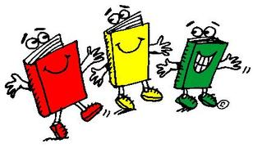
Beginning June 2, 2017
Ending August 27, 2017
Magazines, comic books, and graphic novels everything count!
*Mrs. Stanley’s definition of “more” is rather flexible. Sometimes it simply means “you read MORE than you ever have!” Or, “you read MORE than you thought you would!” Or, even “you worked really hard!” If you fill out a tracking sheet, bring it in, even if you didn’t beat Mrs. Stanley.
Beat Mrs. Stanley Tracking Sheet
Turn in to Mrs. Stanley by September 1, 2017
Dates for this contest are from June 2 to August 27, 2017

If you need more space, just copy this sheet, or check the Library Website for another one.
http://brauchle-library.weebly.com/ (click the Summer Reading tab)
Number | Date | Title & Author | Parent  Signature
Want to know what
Mrs. Stanley is reading?

Follow Brauchle Library on:
martystanley99

Brauchle Library
https://www.facebook.com/BrauchleElementaryLibrary/
@MartyStanley99
She’ll be posting her progress and videos of the books she reads so you can see if you’re beating her!
Summer Reading
Around Town!
Many businesses around town have
Summer Reading programs where you
can earn all sorts of prizes!
(For active links, visit the Library Website:
brauchle-library.weebly.com
and click on the Summer Reading tab)

San Antonio Public Library
Build a better world… through reading!
http://mysapl.org/Summer-Reading

Barnes and Noble
Earn a free book!
http://www.barnesandnoble.com/b/summer-reading/_/N-rs9
Summer Reading Around Town Continued…

Harper Collins
A FREE downloadable Summer Reading guide featuring fantastic middle grade authors (4th through 6th) like Sharon Creech, Katherine Applegate, Gordon Korman, and more!
https://goo.gl/I9WBNx

Chuck E. Cheese
Kids can earn 10 free tokens by reading each day for two weeks. Click on Reading Rewards Calendar. https://goo.gl/Ue5m0q

Half Price Books
Feed Your Brain Summer Reading Program gives out Bookworm Bucks to kids (14 and under) who read for 300 minutes each month during June and July. https://b.hpb.com/fyb/started/

H-E-Buddy Reading Club
Read 10 books, record them on the form, mail it in by 10/1/17, and get a special t-shirt!
https://goo.gl/DYqoz2

Visit the
Brauchle Library
Webpage for even more
Summer Reading
Fun!

brauchle-library.weebly.com

You can download this packet in case you need more tracking sheets, visit links to all the programs mentioned on the previous page, find reading lists for recommended books, and more!
Click on the Summer Reading tab!

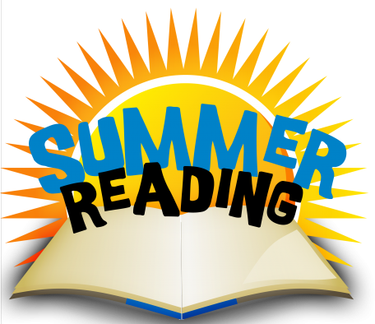

Summer Reading Fun @ Maverick Library
8700 Mystic Park

Come relax and read with some of our
Brauchle teachers!

(See reverse side for details.)

Time: 12:00 PM – 1:00 PM
Tuesdays
June 13th - get a giant READ sticker to color

June 20th - make a silly corner bookmark

June 27th – make a pinwheel

July 11th – make a Lego Batman finger puppet

July 18th – it’s a surprise!

